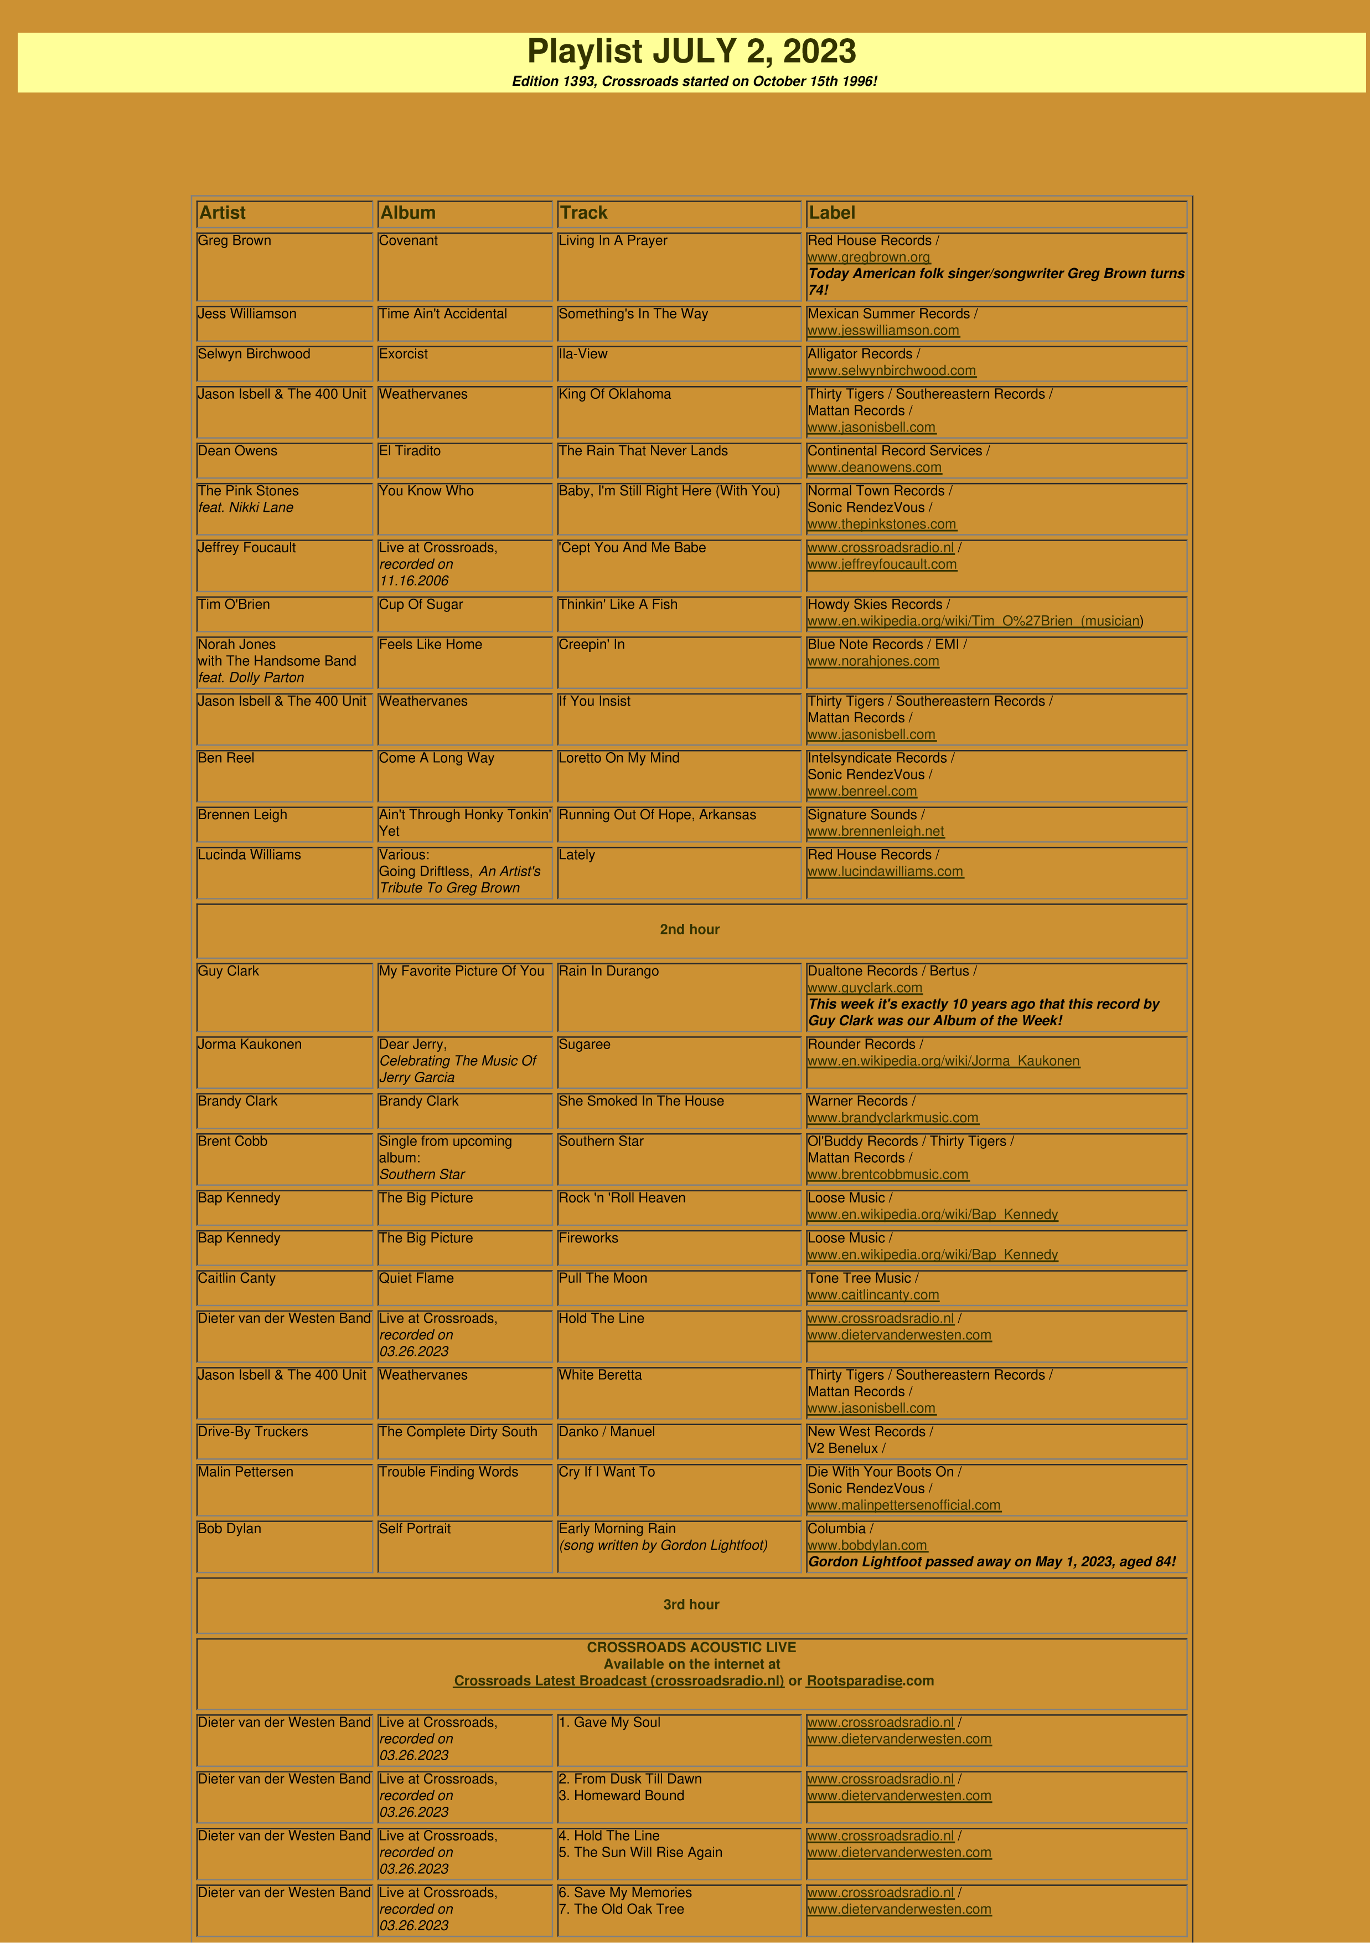

Ben Reel & Band
Live at Crossroads,
recorded on
04.17.2018
. Waiting For A Train
1
2
. Back On The Road Again
www.crossroadsradio.n
l
/
www.benreel.co
m
Ben Reel & Band
Live at Crossroads,
recorded on
04.17.2023
3
. Fish Out Of The Water
4
. One Of These Days
www.crossroadsradio.n
l

/
m
www.benreel.co
Ben Reel & Band
Live at Crossroads,
recorded on
04.17.2023
5
. Soldier Of Love
www.crossroadsradio.n
l

/
www.benreel.co
m

Crossroads Radio
Jos van den Boom
Zuidzijde Haven 55
4611 HC Bergen op Zoom
The Netherlands
www.crossroadsradio.n
l

www.rootsparadise.co
m

www.crossroadssessies.n
l

\

