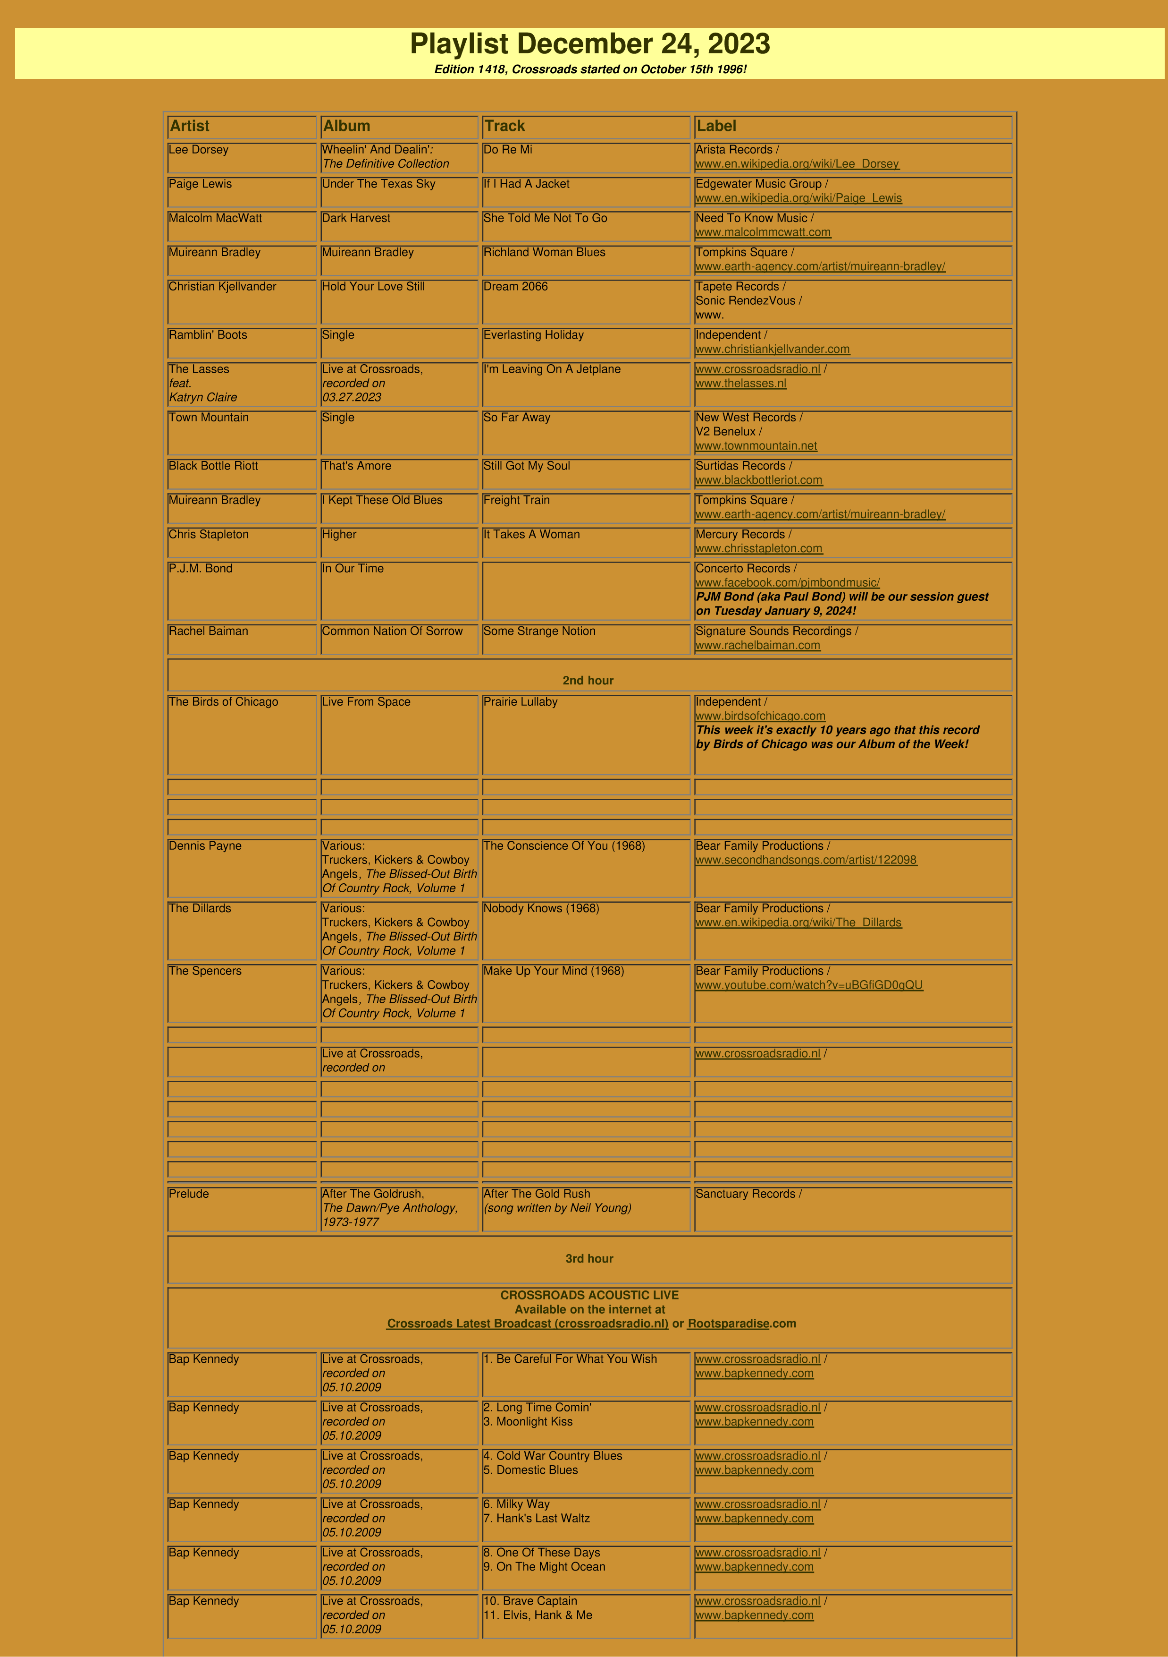

Bap Kennedy
Live at Crossroads,
recorded on
05.10.2009
12
. The Right Stuff
13
. Irish Moon
www.crossroadsradio.n
l

/
m
www.bapkennedy.co
Bap Kennedy
Live at Crossroads,
recorded on
05.10.2009
14
. Mostly Water
www.crossroadsradio.n
l

/
www.bapkennedy.co
m

Crossroads Radio
Jos van den Boom
Zuidzijde Haven 55
4611 HC Bergen op Zoom
The Netherlands
www.crossroadsradio.n
l

www.rootsparadise.co
m

www.crossroadssessies.n
l

\

