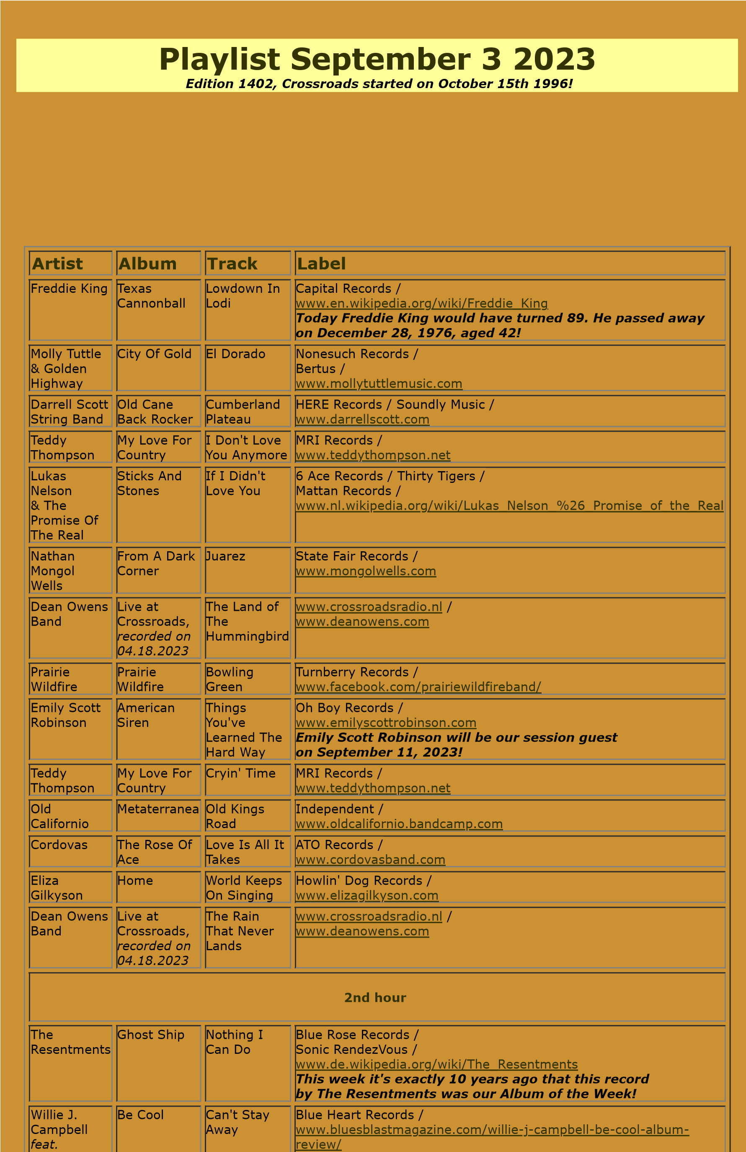
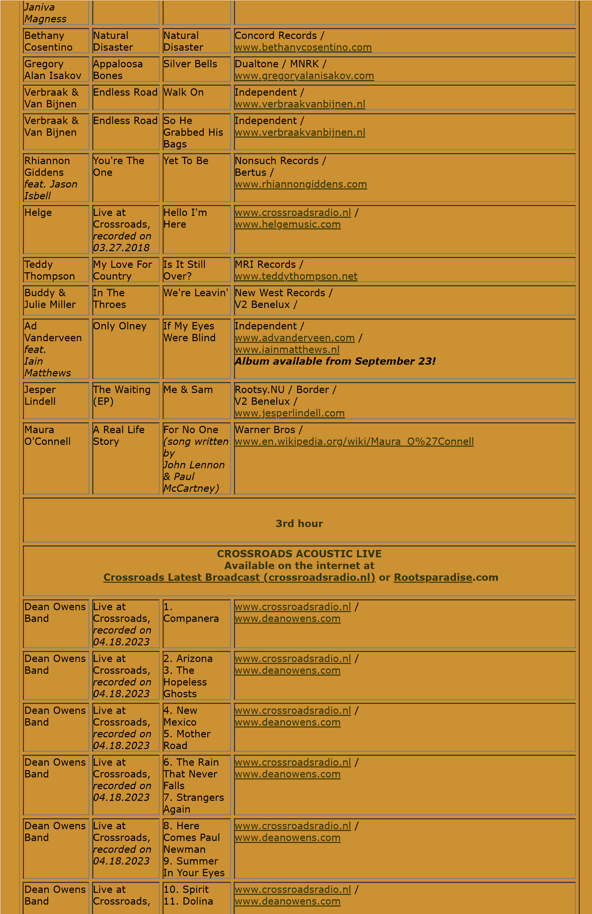
recorded on
04.18.2023
Dean Owens
Band
Live at
Crossroads,
recorded on
04.18.2023
12
. The
Night Johnny
Cash Played
San Quitin
. The
13
Ghost Of
Wild Horses
www.crossroadsradio.n
l

/
m
www.deanowens.co

Crossroads Radio
Jos van den Boom
Zuidzijde Haven 55
4611 HC Bergen op Zoom
The Netherlands
www.crossroadsradio.n
l
www.roots
paradise.co
m
www.crossroadssessies.n
l

\

